# Integrating Machine Learning and Black-Litterman for Adaptive Portfolio Optimization

Backtest result

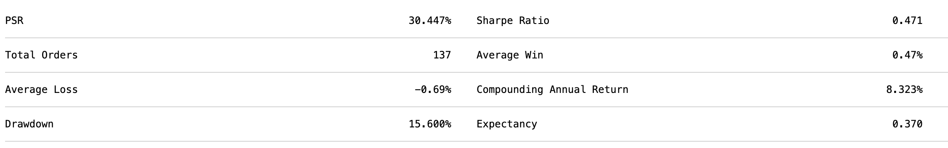

Max drawdown and Sharpe ratio

## Background and Initial Strategy

The strategy development started with the implementation of a base model inspired by the paper "Portfolio Optimization Using Machine Learning." (Obeidat et al., 2018). The core idea of this initial strategy was to leverage Principal Component Analysis (PCA) for dimensionality reduction, followed by using Long Short-Term Memory (LSTM) networks for feature generation and return predictions. The assets considered in this strategy included key ETFs such as the S&P 500 (SPY), Emerging Markets ETF (EEM), as well as various Treasury ETFs and dividend-focused stocks. The PCA was employed to reduce the dimensionality of the feature space, making the data more manageable and emphasizing the most important factors. The LSTM model was then used to predict returns based on these reduced features, capturing both short-term and long-term dependencies in the time series data.

The original strategy utilized the Mean-Variance Optimization (MVO) method, a traditional approach that seeks to balance returns and risk by optimizing the portfolio’s asset allocation based on historical data and covariance estimates. However, during the strategy’s testing phase, particularly in a hackathon setting, it became apparent that there was an opportunity to enhance this model further.

## Strategy Enhancement: Black-Litterman Model (Idzorek, 2007; Kara, Ulucan & Atici, 2019)

The key enhancement introduced to the strategy was the incorporation of the Black-Litterman model, which offered significant improvements over the traditional MVO approach. The Black-Litterman model allows for the integration of subjective views of the investor into the return expectations, thereby not solely relying on historical data. This addition brought a new layer of customization and flexibility to the portfolio construction process.

By implementing the Black-Litterman model, the strategy was able to incorporate views such as the expectation that the S&P 500 would outperform other indices like EFA (MSCI EAFE ETF) and that Emerging Markets would deliver modest returns of around 2%. These views were informed by considerations such as the interest rate cycles and their impact on emerging markets, which had experienced challenges in recent years due to fluctuating rates.

To implement this, the strategy calculated the P and Q matrices, representing the views and their expected returns, respectively. The model also allowed for setting the Ω matrix, which quantifies the uncertainty associated with these views. This approach not only provided a framework to blend historical data with forward-looking views but also made the strategy more robust and diversified, capable of adapting to different market conditions.

## Asset Selection and Performance

The asset universe for the strategy included major indices like the S&P 500 and Emerging Markets ETF, alongside Treasury ETFs and other diversifying assets such as the US Dollar Index and gold. During the testing phase, other assets like real estate indices were considered but ultimately excluded due to underperformance. The strategy was fine-tuned to focus on the assets that aligned with the investor's views and the expected macroeconomic environment.

The strategy successfully achieved a 40% return over a five-year period, which was considered reasonable given the market conditions and the balanced risk-return profile it aimed to maintain. The integration of the Black-Litterman model provided a structured way to incorporate subjective views, enhancing the strategy’s ability to perform in varying market environments.

## Conclusion

This strategy exemplifies a thoughtful blend of machine learning techniques and modern portfolio theory, enhanced by the Black-Litterman model. By starting with a solid foundation based on PCA and LSTM, and then advancing to include investor-specific views through the Black-Litterman approach, the strategy achieved a well-rounded performance. The consideration of macroeconomic factors and the selective inclusion of assets ensured that the strategy was not only data-driven but also contextually relevant. The resulting 42% return over five years underscores the effectiveness of this multi-faceted approach, making it a robust and adaptable investment strategy.

## References

Idzorek, T. (2007). A step-by-step guide to the Black-Litterman model: Incorporating user-specified confidence levels. In *Forecasting expected returns in the financial markets* (pp. 17-38). Academic Press.

Kara, M., Ulucan, A., & Atici, K. B. (2019). A hybrid approach for generating investor views in Black–Litterman model. *Expert Systems with Applications*, *128*, 256-270.

Obeidat, S., Shapiro, D., Lemay, M., MacPherson, M. K., & Bolic, M. (2018). Adaptive portfolio asset allocation optimization with deep learning. *International Journal on Advances in Intelligent Systems*, *11*(1), 25-34.